Project: Web Page Title Scrape

Introduction
Web scraping is a technique used to extract information from websites automatically. This project demonstrates how to extract and display the title of a web page using the BeautifulSoup library in Python. The title tag is an essential metadata element that provides a concise description of the webpage content, often used in search engine optimization (SEO) and browser tab labels.

_____________________________________________

Problem Statement
The goal of this project is to extract and display the title of a given web page using Python and BeautifulSoup.
_____________________________________________

Objectives
- Send an HTTP request to a target URL.
- Parse the HTML content using BeautifulSoup.
- Retrieve and display the

_____________________________________________

Tools & Technologies

- Python 3.x – Programming language.
- Requests – To send HTTP requests and fetch webpage content.
- BeautifulSoup (bs4) – To parse and extract data from HTML.

_____________________________________________

Methodology

Step 1: Import Libraries
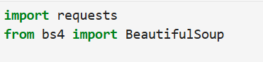

Step 2: Define the URL
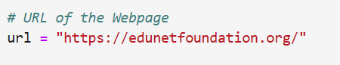

Step 3: Send HTTP Request
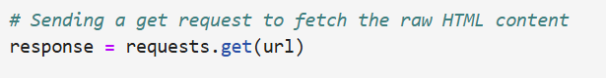

Step 4: Parse HTML Content
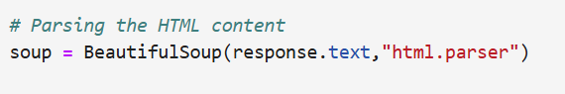

Step 5: Extract Title
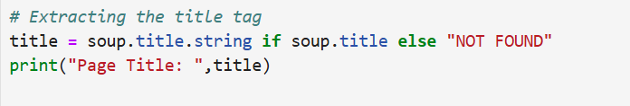

_____________________________________________

Sample Output
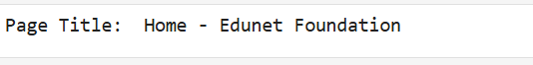

_____________________________________________

Applications
- SEO Analysis – Extracting metadata for optimization.
- Web Crawlers – Summarizing webpage information.
- Automation – Quick retrieval of webpage titles for indexing
_____________________________________________

Limitations
- Works only if the webpage has a Title.
- Requires internet connectivity.
- Cannot handle JavaScript-rendered titles without additional tools (e.g., Selenium).

_____________________________________________

Conclusion
This project successfully demonstrates how to use Python and BeautifulSoup to extract the title of a webpage. It provides a foundation for more advanced web scraping tasks, such as extracting headings, metadata, or structured data from websites.

